SMART MOTION SECURITY SYSTEM

1. Introduction
An Embedded System is a microcontroller-based system designed to perform a specific task. In this project, we designed a Smart Motion Security System using Arduino UNO and a PIR sensor. This system detects motion and automatically triggers an alert using an LED and a buzzer. It demonstrates basic home and office security automation.

2. Objective
- Detect human motion using a PIR sensor.
- Automatically activate LED and buzzer when motion is detected.
- Display system status on Serial Monitor.
- Implement IF–ELSE automation logic.

3. Components Used
- Arduino UNO
- PIR Motion Sensor
- LED
- 220Ω Resistor
- Buzzer
- Breadboard
- Jumper Wires
- Tinkercad Simulation Platform

4. Circuit Connections
PIR Sensor:
VCC → 5V
GND → GND
OUT → Digital Pin 2
LED:
Long leg (+) → Digital Pin 3
Short leg (–) → Resistor → GND
Buzzer:
Positive (+) → Digital Pin 4
Negative (–) → GND
All GND connections are connected together.
Wiring Circuit Image
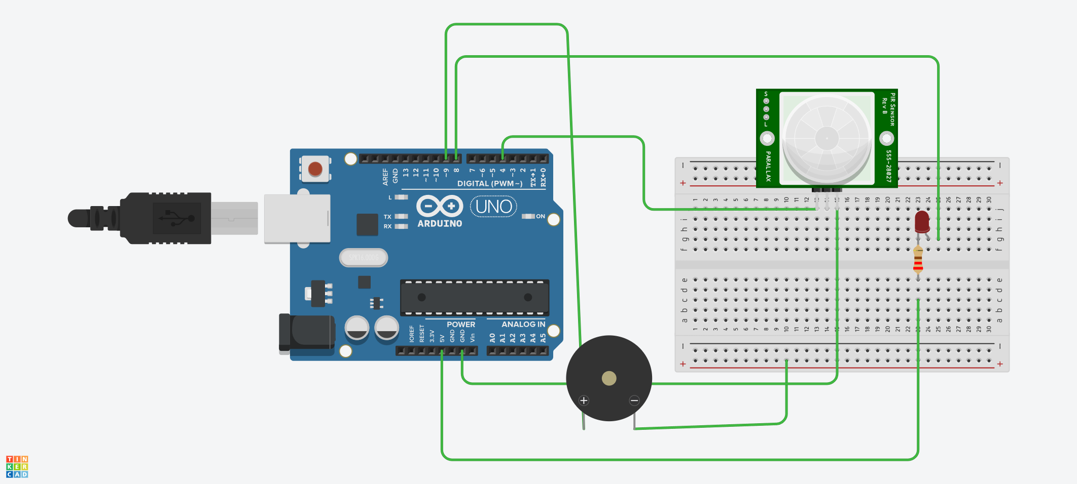

5. Source Code
int pirPin = 2;
int ledPin = 8;
int buzzerPin = 9;
void setup() {
Serial.begin(9600);
pinMode(pirPin, INPUT);
pinMode(ledPin, OUTPUT);
pinMode(buzzerPin, OUTPUT);
}
void loop() {
int motion = digitalRead(pirPin);
if (motion == HIGH) {
digitalWrite(ledPin, HIGH);
digitalWrite(buzzerPin, HIGH);
Serial.println("⚠ INTRUDER ALERT!");
}
else {
digitalWrite(ledPin, LOW);
digitalWrite(buzzerPin, LOW);
Serial.println("Area Safe");
}
delay(500);
}

6. Working Explanation
The PIR (Passive Infrared) sensor detects infrared radiation changes caused by human movement. When motion is detected, the PIR output becomes HIGH. The Arduino reads this signal and turns ON the LED and buzzer while displaying 'INTRUDER ALERT' on the Serial Monitor. When no motion is detected, the output becomes LOW, and the LED and buzzer turn OFF while displaying 'Area Safe'. The system uses IF–ELSE logic to automate this process.
Working Image
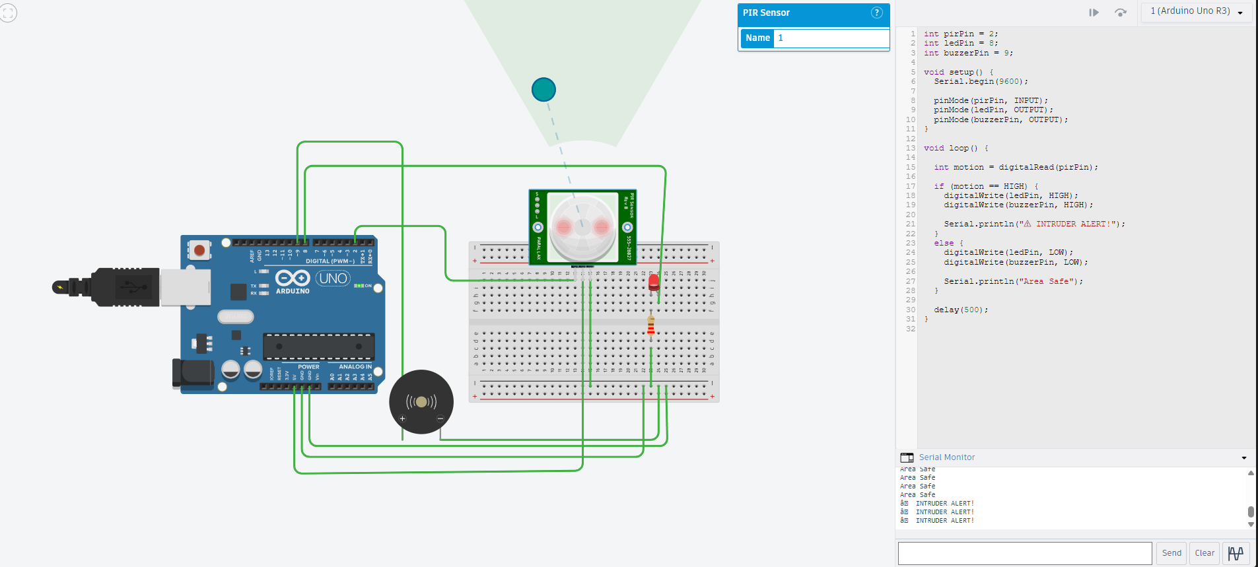

7. Applications
- Home Security Systems
- Office Intrusion Detection
- Warehouse Monitoring
- Smart Automation Systems
- Industrial Safety Systems

8. Conclusion
The Smart Motion Security System successfully demonstrates sensor-based automation using Arduino. This project improves understanding of embedded systems, sensor interfacing, automation logic, and real-time monitoring.

